**TRIBHUVAN UNIVERSITY**

**INSTITUTE OF ENGINEERING**

**KATHMANDU ENGINEERING COLLEGE**

**KALIMATI, KATHMANDU**

A

Major Project Proposal

Defense Report

On

**“Advancing Tomato Harvesting: An Automation with Machine Learning Approach”**



**Submitted By:**

Mausam Gurung (KAT076BEI014)

Shalon Maharjan (KAT 076BEI027)

Shubham Bista(KAT076BEI028)

Symon Shrestha (KAT076BEI030)

**Submitted To:**

**DEPARTMENT OF ELECTRONICS, COMMUNICATION**

**AND INFORMATION ENGINEERING**

**July-2023**

# ACKNOWLEDGEMENT

We would like to express our sincere appreciation to Sir Er. Sagun Manandhar and Mam Er. Pushpa Dhamala, our Minor Project supervisors, for their unwavering support and guidance throughout the project, helping us turn our ideas into reality. Their valuable experience served as a guide, instilling us with the confidence and curiosity to tackle problems and see the bigger picture.

We are also deeply grateful to Er. Rajan Lama, the Head of the Department of Electronics, Communication, and Information Engineering, for providing us with the opportunity to work on this project. Our heartfelt thanks go out to our project coordinator, Er. Dipen Manandhar, for effectively managing and coordinating the project, and for his timely support and guidance.

We would like to extend our gratitude to all the teaching staff of the Department of Electronics, Communication, and Information Engineering for their constant encouragement, support, constructive criticism, and guidance, and for their keen interest in our project. We are also fortunate to have received support from research paper authors whose interest in our work helped to clear up any blind spots we encountered and refine our ideas. Without their support, our project would not have progressed as smoothly.

# ABSTRACT

The agricultural industry continually seeks innovative solutions to enhance productivity, address labor shortages, and optimize crop harvesting processes. In this context, the development of an autonomous tomato harvesting robot equipped with machine learning capabilities presents a promising approach.

Our project aims to design and implement an autonomous tomato harvesting robot with a 6DOF robotic hand and a machine learning-based recognition system. The robot's 6DOF robotic hand enables precise and gentle fruit detachment from tomato plants, minimizing crop damage and wastage. The machine learning-based recognition system, employing Histograms of Oriented Gradients (HOG) features and a Support Vector Machine (SVM) classifier, accurately identifies and locates ripe tomatoes in a tomato field.

# TABLE OF CONTENTS

Contents

ACKNOWLEDGEMENT i

ABSTRACT ii

TABLE OF CONTENTS iii

LIST OF FIGURES v

LIST OF ABBREVATION vi

CHAPTER 1: INTRODUCTION 1

1.1 Background Theory 1

1.2 Problem Statement 2

1.3 Objectives 3

1.4 Scope and Applications 3

1.5 Organization of Project Report 4

CHAPTER 2: LITERATURE REVIEW 6

CHAPTER 3: RELATED THEORY 8

3.1 Hardware 8

3.1.1 Arduino Mega2560 8

3.1.2 HC-05 Bluetooth 8

3.1.3 HC-SR04 ultrasonic sensor 9

3.1.4 Accelerometer sensor with gyroscope 10

3.1.5 Brushless DC Motor 11

3.1.6 Driving DC motor 11

3.1.7 Li-ion polymer battery 12

3.1.8 9*6E Propeller 13

3.1.9 L293D Dc motor Driver shield 13

3.1.10 Potentiometer 14

3.2 Software 15

CHAPTER 4: METHODOLOGY 16

4.1 Block Diagram 16

4.2 Algorithm 17

4.3 Flowchart 18

18

CHAPTER 5: EXPECTED RESULT 22

CHAPTER 6: TIME SCHEDULE 23

6.1 Gantt chart 23

GANTT CHART (TIME SCHEDULE) 23

CHAPTER 7: COST ESTIMATION 24

REFERENCES 25

# LIST OF FIGURES

Figure 1: Arduino Mega 2560 8

Figure 2: HC-05 Bluetooth module 9

Figure 3: Ultrasonic sensor 10

Figure 4: Accelerometer sensor with gyroscope 10

Figure 5: Brushless DC motor 11

Figure 6: Driving DC motor 12

Figure 7: Li-ion polymer battery 12

Figure 8: 9*6E Popeller 13

Figure 9: L293D motor Driver shield 14

Figure 10: Potentiometer 14

Figure 11: Block Diagram 16

Figure 12: General Flowchart of wall climbing robot 18

Figure 13: Motor movement flowchart 19

Figure 14: Flowchart for reverse thrust creation 20

Figure 15: Assign work : cleaning flowchart 21

Figure 16: Flowchart of camera as feedback system 21

# LIST OF ABBREVATION

HOG: Histogram of Oriented Gradient

Li-ion: Lithium-Ion battery

SVM: Sector Vector Machine

# CHAPTER 1: INTRODUCTION

## 1.1 Background Theory

The agricultural industry is continually seeking innovative solutions to address labor shortages, enhance productivity, and improve harvesting efficiency. In recent years, autonomous harvesting robots have emerged as a promising technology to revolutionize the way crops are harvested. This report presents the design and implementation of an autonomous tomato harvesting robot equipped with a 6 Degrees of Freedom (6DOF) robotic hand and a machine learning-based recognition system. The primary objectives of this research are to optimize the Harvesting Mechanism, develop an efficient Recognition System for ripe tomato identification, and design robust and precise movement capabilities for the robot. There are three function we need to consider for the design of robot. They are:

### 1.1.1 Harvesting Mechanism:

The Harvesting Mechanism is a crucial component of the autonomous tomato harvesting robot. The primary goal is to ensure a gentle yet efficient method of detaching ripe tomatoes from the plant to minimize damage and preserve the crop's quality. This advanced robotic hand offers greater dexterity and versatility, allowing the robot to handle delicate tomatoes with precision and efficiency.

### 1.1.2 Recognition System:

Accurate recognition of ripe tomatoes is essential for the efficient operation of the harvesting robot. To achieve this, we implement a machine learning-based Recognition System using advanced computer vision techniques. The system employs Histograms of Oriented Gradients (HOG) features and a Support Vector Machine (SVM) classifier to identify and locate ripe fruits accurately. By training the machine learning model on a vast dataset of tomato images, the robot can intelligently differentiate between ripe and unripe tomatoes, enhancing its harvesting capabilities.

### 1.1.3 Movement System:

The movement of a harvesting robot on wheels involves the integration of sophisticated control systems and motion planning algorithms. These elements allow the robot to traverse uneven terrains within the agricultural fields, seamlessly maneuvering around crop rows and obstacles. The agility and speed of the robot's movement are crucial in optimizing harvesting efficiency and reducing time-consuming manual labor.

Additionally, the design and implementation of wheel movement mechanisms must ensure minimal soil compaction to preserve the soil's health and fertility. The capability to move smoothly and with precision is paramount to minimize crop damage during the harvesting process.

## 1.2 Problem Statement

The traditional manual harvesting of tomatoes in agricultural practices is labor-intensive and time-consuming, leading to increased production costs and inefficiencies in crop harvesting. The lack of an automated and efficient harvesting solution poses a significant challenge to the agricultural industry. Moreover, accurately identifying ripe tomatoes amidst foliage can be challenging, resulting in potential crop damage and wastage. To address these issues, there is a pressing need for the design and implementation of an autonomous tomato harvesting robot with advanced recognition capabilities and precise harvesting mechanisms to improve productivity, reduce labor dependence, and ensure optimal crop quality.

## 1.3 Objectives

* Develop an autonomous tomato harvesting robot with a 6DOF robotic hand and optimized movement capabilities for precise and gentle fruit detachment from the plant, efficient navigation through tomato plants, and avoidance of obstacles.
* To Implement a machine learning-based Recognition System using HOG features and SVM classifier to accurately identify and locate ripe tomatoes.

## 1.4 Scope and Applications

* Revolutionizing agricultural practices by enhancing harvesting efficiency and reducing manual labor dependency.
* Improving crop productivity and quality by minimizing crop damage and wastage during harvesting.
* Adapting the autonomous harvesting robot for various greenhouse and field cultivation setups.
* Enhancing sustainability in agriculture through the efficient use of resources and reduced environmental impact.
* Potential application in other fruit and vegetable harvesting tasks to address labor shortages and improve production efficiency in the agricultural industry.

## 1.5 Organization of Project Report

The material presented in this report is organized into five chapters: Chapter 1 consists of the introduction, objective, and background of the project. The scope and application of the project are also discussed. Chapter 2 deals with the literature review that describes the past works and research that were done related to this project and the methodology that was used in those projects. Chapter 3 discusses the conceptual theories about various related aspects, and components used. Chapter 4 describes the methodology, basic design, outline, and process of the project, and Chapter 5 consists of the expected outputs/results. Finally, Chapter 6 consists of the epilogue of the project.

# CHAPTER 2: LITERATURE REVIEW

On this paper author focuses on the design and development of an autonomous tomato harvesting robot, which aims to address labor shortages and boost crop productivity in agriculture. The robot's key elements include harvesting, recognition, and movement. It utilizes a plucking mechanism with a rotational gripper for efficient tomato harvesting and integrates a color camera for fruit recognition. The review highlights the importance of improving recognition methods to increase the harvesting rate and discusses challenges, such as grasp state estimation and simultaneous recognition of fruit and stem positions. The robot's evaluation through extensive harvesting experiments in diverse environments is also explored. [1]

This research article introduces a method for detecting mature tomatoes using computer vision techniques, with a particular focus on applying machine learning and color analysis to achieve precise tomato detection. The authors utilize Histograms of Oriented Gradients (HOG) features and a Support Vector Machine (SVM) classifier for the detection process. The article provides an in-depth description of the HOG feature extraction process, SVM classifier training, and the adoption of a sliding window approach to identify tomatoes. [2]

In this document the author focuses on design and testing of a tomato harvesting robot equipped with a vision positioning system and a picking gripper for efficient tomato harvesting. The robot's control system comprises an information acquisition unit, IPC operation control unit, and motion execution unit. Tested in a greenhouse, the robot achieved a successful tomato harvesting rate of 83.9%. Its primary goal is to enhance efficiency and reduce labor in tomato harvesting processes. [3]

This document focuses on the design and research of the end actuator of a tomato picking robot The end effector, comprising hardware components such as fingers, vacuum corrugated suckers, bidirectional screws, DC servo motors, and more, plays a vital role in achieving successful fruit and vegetable picking. [4]

The paper focuses on the design of a chassis system for a tomato picking robot in a greenhouse. It provides detailed information on the mechanical structure design, girder assembly, and drive line, as well as the overall layout of the chassis. Additionally, it discusses the components' functions, such as the mounting frame for the picking system and the control system installation area. The paper also covers the design of the power supply circuit and control program. [5]

# CHAPTER 3: RELATED THEORY

## 3.1 Hardware

### 3.1.1 Arduino Mega2560

The Arduino Mega2560 is a microcontroller board that offers an extensive range of digital and analog input/output pins, making it a powerful and versatile platform for various electronics projects. It is based on the ATmega2560 microcontroller and provides ample resources for complex tasks and applications. With 54 digital input/output pins, 16 analog inputs, 4 UARTs (hardware serial ports), a 16 MHz crystal oscillator, a USB connection, and a power jack, the Arduino Mega2560 allows for the connection and control of numerous sensors, actuators, and other electronic components. Its generous number of pins and abundant memory enable it to handle large-scale projects, such as home automation systems, robotics, and data logging applications. Overall, the Arduino Mega2560 is an excellent choice for advanced projects that require extensive input/output capabilities and high processing power.

Figure 1: Arduino Mega 2560

### 3.1.2 HC-05 Bluetooth

The HC-05 Bluetooth module is a versatile component that enables wireless communication between devices. It acts as a bridge between the system and external devices, allowing for seamless data transmission over short distances. The module supports Bluetooth version 2.0 and has a range of approximately 10 meters, making it suitable for a wide range of applications. It features a serial communication interface that facilitates easy integration with microcontrollers, such as Arduino, and other electronic devices. The HC-05 module supports both master and slave modes, providing flexibility in establishing connections. With its compact size, low power consumption, and reliable performance, the HC-05 Bluetooth module is an excellent choice for implementing wireless connectivity in various projects, including home automation, robotics, and IoT applications.

Figure 2: HC-05 Bluetooth module

### 3.1.3 HC-SR04 ultrasonic sensor

The HC-SR04 ultrasonic sensor is a widely used and versatile component in robotics and automation systems. This sensor operates on the principle of echolocation, emitting ultrasonic sound waves and measuring the time it takes for the waves to bounce back after hitting an object in its path. With its compact size and easy integration, the HC-SR04 sensor is capable of detecting obstacles and estimating distances accurately. It emits ultrasonic waves within a specified range and uses the reflected signals to calculate the distance between the sensor and the object. The sensor consists of a transmitter and a receiver, which work in tandem to transmit and receive ultrasonic signals. By utilizing the time-of-flight measurement technique, the HC-SR04 can provide distance measurements with high precision. This sensor is particularly useful for obstacle detection and avoidance in robotics applications, enabling robots to navigate their environment safely. Its affordability, simplicity, and reliability make it a popular choice for hobbyists, educators, and professionals alike.

Figure 3: Ultrasonic sensor

### 3.1.4 Accelerometer sensor with gyroscope

An accelerometer sensor, combined with a gyroscope, forms a powerful sensor unit that provides comprehensive motion sensing capabilities. The accelerometer measures linear acceleration in three axes, allowing it to detect changes in speed and direction. It enables the system to track movements such as tilting, shaking, or linear acceleration. On the other hand, the gyroscope measures angular velocity and rotation around the three axes, providing information about the device's orientation and rotational movements. By combining the data from both sensors, the system can accurately determine the device's position, track its motion in three-dimensional space, and enable applications such as gesture recognition, motion tracking, and virtual reality experiences. This sensor combination enhances the system's ability to interpret and respond to real-world movements, making it valuable in various fields, including robotics, gaming, and mobile devices.

Figure 4: Accelerometer sensor with gyroscope

### 3.1.5 Brushless DC Motor

A brushless DC (BLDC) motor is an electric motor that operates using a permanent magnet rotor and a rotating magnetic field generated by the stator. Unlike traditional brushed motors, BLDC motors do not rely on brushes and commutators for electrical contact, resulting in improved efficiency, reliability, and longevity. The rotor's permanent magnets interact with the stator's electromagnets, which are energized in a sequence determined by an electronic controller. This sequential energization produces a rotating magnetic field that drives the rotor, enabling smooth and precise rotational motion. BLDC motors are widely used in various applications, including robotics, electric vehicles, industrial machinery, and HVAC systems, due to their high-power density, low maintenance requirements, and precise speed control capabilities.

Figure 5: Brushless DC motor

### 3.1.6 Driving DC motor

Driving a DC motor involves providing the necessary electrical signals to control its speed and direction of rotation. The motor is typically powered by a direct current (DC) source, such as a battery or power supply. To control the motor's speed, a pulse width modulation (PWM) technique is commonly employed. By varying the duty cycle of the PWM signal, the average voltage applied to the motor can be adjusted, thus regulating its rotational speed. Additionally, the direction of rotation can be controlled by using an H-bridge circuit, which allows the current to flow in either direction through the motor coils. By selectively activating the appropriate transistors in the H-bridge, the motor can be made to rotate clockwise or counterclockwise. Overall, driving a DC motorentails manipulating the electrical signals through PWM and H-bridge techniques to regulate both the speed and direction of the motor's rotation.

Figure 6: Driving DC motor

### 3.1.7 Li-ion polymer battery

A Li-ion polymer battery is a type of rechargeable battery that utilizes lithium-ion technology. It is characterized by a lightweight and flexible design, making it suitable for various portable electronic devices such as smartphones, tablets, and laptops. The battery consists of multiple cells, each containing a lithium-based electrolyte and electrodes. During charging, lithium ions move from the positive electrode (cathode) to the negative electrode (anode), and during discharge, the process is reversed. Li-ion polymer batteries offer high energy density, allowing them to store a significant amount of energy in a compact size. They also exhibit low self-discharge rates, retaining their charge for extended periods. Additionally, Li-ion polymer batteries are known for their excellent cycle life, enabling them to withstand numerous charge and discharge cycles before experiencing a significant capacity decline. Overall, Li-ion polymer batteries provide a reliable and efficient power source for portable electronic devices.

Figure 7: Li-ion polymer battery

### 3.1.8 9*6E Propeller

The 96E propeller is an essential component used in various applications, especially in the field of unmanned aerial vehicles (UAVs) and remote-controlled aircraft. This propeller features a diameter of 9 inches and a pitch of 6 inches, indicating its size and the distance the propeller would travel in one complete rotation. The "E" designation signifies its specific design characteristics, such as the shape of the blades and the materials used. With its efficient design, the 96E propeller is capable of generating significant thrust and lift, allowing for stable and controlled flight. Its precise construction ensures optimal balance and performance, contributing to improved maneuverability and overall flight dynamics. Whether for hobbyist or professional applications, the 9*6E propeller is a reliable choice that enhances the efficiency and performance of aerial systems.

Figure 8: 9*6E Popeller

### 3.1.9 L293D Dc motor Driver shield

The L293D DC motor driver shield is a versatile electronic module that provides an interface between a microcontroller and DC motors. It features the L293D chip, which is a dual H-bridge motor driver capable of driving two separate DC motors with bidirectional control. The shield is designed to simplify the process of controlling motors, allowing users to easily connect and control motors using a microcontroller such as Arduino. It offers various features such as current sensing, built-in protection diodes, and screw terminal connectors for motor connections. The L293D DC motor driver shield is an essential component for projects that require precise control and manipulation of DC motors, providing a convenient and reliable solution for motor control applications.

Figure 9: L293D motor Driver shield

### 3.1.10 Potentiometer

A potentiometer, also known as a variable resistor, is an electronic component that allows for the adjustment of electrical resistance. It consists of a resistive element, typically a long, coiled wire or a carbon film, with a sliding contact called the wiper. By moving the wiper along the resistive element, the effective length of the resistive path can be changed, thereby varying the resistance. This adjustment can be done manually, allowing users to control the flow of current or voltage in a circuit, adjust volume levels, set parameters in electronic devices, or provide position feedback in mechanical systems. Potentiometers are commonly used in audio equipment, dimmer switches, joysticks, and other applications requiring precise and adjustable electrical resistance.

Figure 10: Potentiometer

## 

## 3.2 Software

3.2.1Raspberry pi software: Linux

Linux is a free open-source operating system and it belongs to the Unix operating systems. Actually, Linux means the kernel itself which is the heart of the operating system and handles the communication between the user and hardware. Normally Linux is used to refer to the whole Linux distribution. Linux distribution is a collection of software based on the Linux Kernel. It consists of the GNU-project's components and applications. Because Linux is an opensource project, anyone can modify and distribute it. That is the reason why there are many variations of Linux distributions. Most popular distributions are Ubuntu, Red Hat Linux, Debian GNU/Linux and SuSe Linux.

5.3 PYTHON

Python is a high-level, interpreted, interactive and object-oriented scripting language. Python is designed to be highly readable. It uses English keywords frequently where as other languages use punctuation, and it has fewer syntactical constructions than other languages.

• Python is interpreted: Python is processed at runtime by the interpreter. You do not need to compile your program before executing it. This is similar to PERL and PHP.

• Python is Interactive: You can actually sit at a Python prompt and interact with the interpreter directly to write your programs.

• Python is Object-Oriented: Python supports Object-Oriented style or technique of programming that encapsulates code within objects.

• Python is a Beginner's Language: Python is a great language for the beginner-level programmers and supports the development of a wide range of applications from simple text processing to WWW browsers to games.

5.3.2 Python’s standard library

* Pandas
* Numpy
* Sklearn
* Seaborn
* Matplotlib
* Importing Datasets
* OpenCV

# CHAPTER 4: METHODOLOGY

## 4.1 Block Diagram



Figure 11: Block Diagram

## 4.2 Algorithm

General algorithm

1. Start
2. Initialize all the device
3. Read the value
4. Start motor rotation for the creation of antithrust
5. Start motor movement for locomotion
6. Assign work
7. Check if work is done.
8. If no follow the step 6.
9. If yes start reading gyroscope sensor
10. Read Accelerometer
11. Read ultrasonic sensor

Flowchart of locomotion

1. Start
2. To move forward
3. If yes move to step 7
4. If no, to take right turn move step 5 to take left turn move to step 6
5. Left motor reduce the speed and right motor increase speed
6. Right motor reduce speed and left motor increase speed
7. Sync the motor and keep moving

Flowchart for cleaning and feedback

1. Start cleaning the wall that are needed to clean
2. Spray liquid to wall
3. Clean the wall through brush
4. Capture the image and check from the database whether the wall is clean or not
5. Notify the controller whether the wall is clean or not
6. If clean move to step 8
7. If not clean follow the step from 2
8. Keep moving forward for cleaning

## 4.3 Flowchart

## 

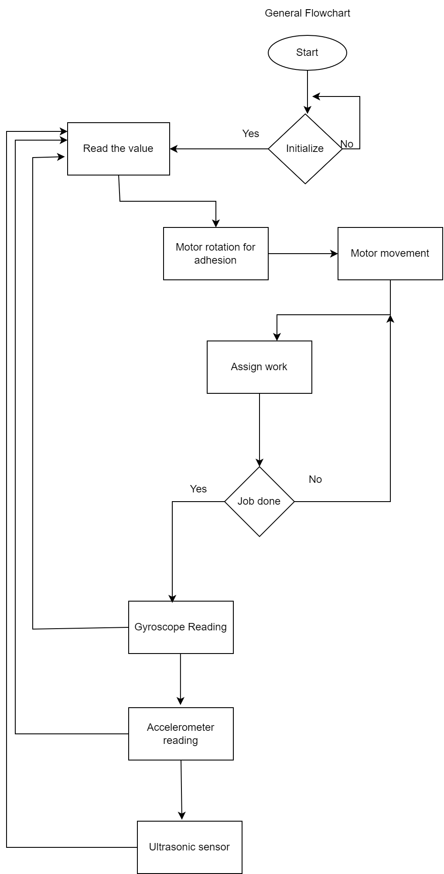

Figure 12: General Flowchart of wall climbing robot

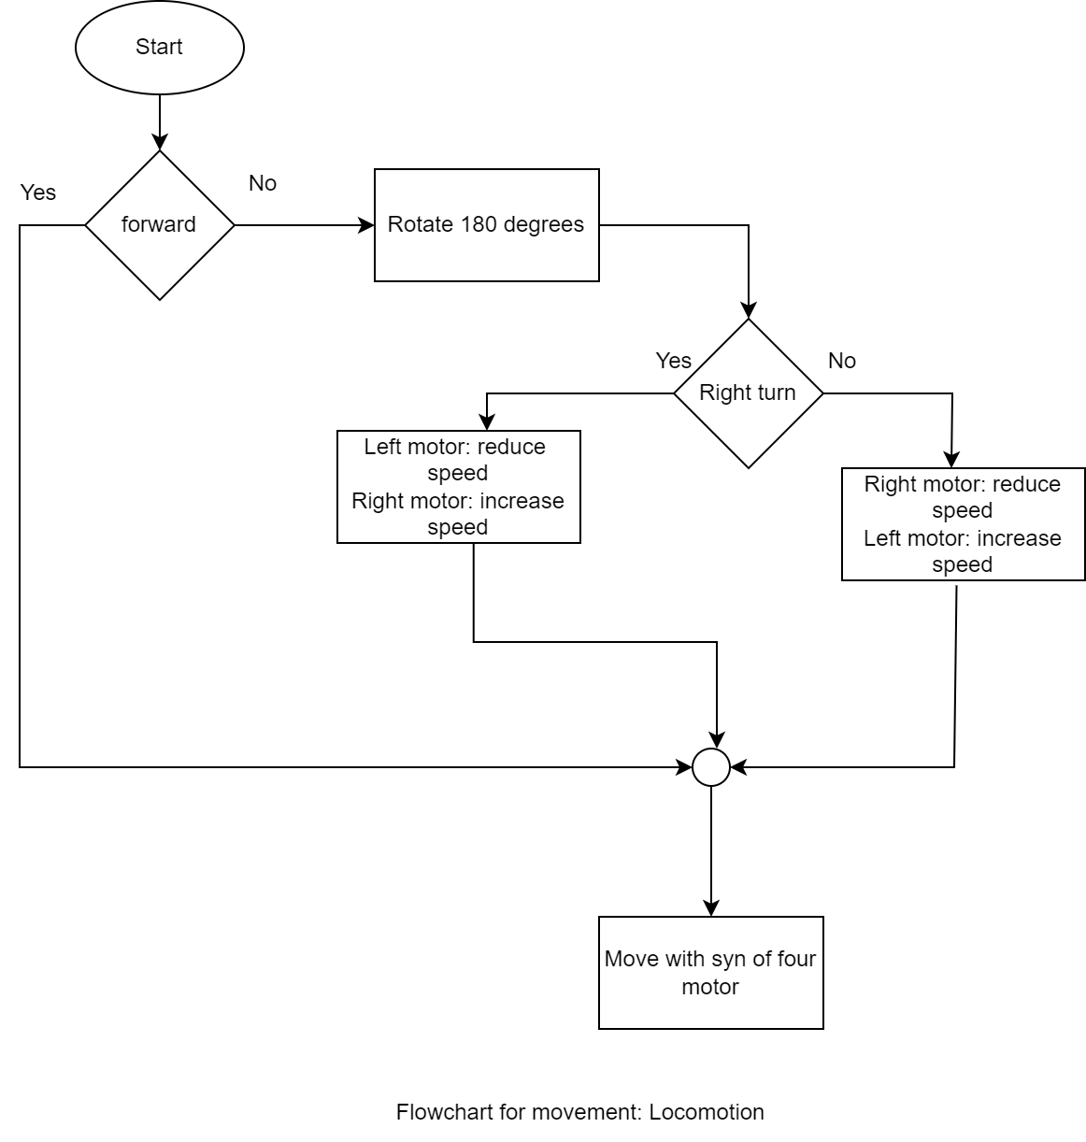

Figure 13: Motor movement flowchart

Figure 14: Flowchart for reverse thust creation

Figure 15: Assign work : cleaning flowchart

Figure 16: Flowchart of camera as feedback system

# CHAPTER 5: EXPECTED RESULT

Our project aims to develop an autonomous tomato harvesting robot with advanced capabilities for efficient and precise harvesting. The key expected results include:

1. Tomato Recognition: Equipped with a sophisticated vision system, the robot will accurately recognize ripe tomatoes using image processing and machine learning algorithms.
2. Distance Calculation and Sorting: The robot will prioritize harvesting the nearest ripe tomatoes for optimized efficiency.
3. Automated Robotic Arm: A 6-degree-of-freedom robotic arm will delicately detach ripe tomatoes to minimize crop damage.
4. Collection Mechanism: Harvested tomatoes will be securely placed in a collecting basket, ensuring smooth and efficient harvesting.
5. Continuous Harvesting: The robot's intelligent navigation system will enable seamless detection and harvesting of ripe tomatoes in the field.
6. Intelligent Basket Management: The robot will autonomously navigate back to a designated common place when the collecting basket reaches its maximum capacity.
7. Resuming Harvesting: After clearing the basket, the robot will resume harvesting from the last point, eliminating duplicate harvesting.

Our project aims to revolutionize tomato harvesting, offering a cost-effective and labor-saving solution that enhances productivity and quality in agriculture. The autonomous robot will contribute to a sustainable and efficient future for tomato harvesting, benefiting farmers and the agricultural community.

# CHAPTER 6: TIME SCHEDULE

## 6.1 Gantt chart

# GANTT CHART (TIME SCHEDULE)

|  |  |  |  |  |  |  |  |  |  |  |  |  |  |  |  |
| --- | --- | --- | --- | --- | --- | --- | --- | --- | --- | --- | --- | --- | --- | --- | --- |
| Task ID | Task Title | Effort (hours) | M  A  Y | J  U  N | J  U  L | A  U  G | S  E  P | O  C  T | N  O  V | D  E  C | J  A  N | F  E  B | M  A  R | A  P  R | DELIVERABLES |
| 1 | Project Initiation | 110 | 38 | 18 | 35 | 8 | 11 |  |  |  |  |  |  |  | Selection of a feasible project |
| 1.1 | Define project objectives and scope | 18 | 18 |  |  |  |  |  |  |  |  |  |  |  | Identifying and writing basic objectives and scope of project |
| 1.2 | Conduct initial research and feasibility analysis | 92 | 20 | 18 | 35 | 8 | 11 |  |  |  |  |  |  |  | Literature review, scope of the project, objectives, methodology and expected output |
| 2 | Requirement Gathering | 60 |  | 15 | 20 | 10 | 15 |  |  |  |  |  |  |  | Essential hardware and software materials |
| 2.1 | Study of existing Robot | 60 |  | 15 | 20 | 10 | 15 |  |  |  |  |  |  |  | Information about the existing robot and things to change and modify |
| 3 | Hardware | 85 |  |  |  |  |  | 20 | 30 | 20 | 15 |  |  |  |  |
| 3.1 | Hardware Implementation | 50 |  |  |  |  |  | 10 | 20 | 10 | 10 |  |  |  | Hardware collection and building a system |
| 3.2 | Programming with Arduino | 35 |  |  |  |  |  | 10 | 10 | 10 | 5 |  |  |  | Programming the system to perform accordingly |
| 4 | Software | 378 |  |  |  | 30 | 35 | 55 | 25 | 45 | 45 | 50 | 45 | 48 |  |
| 4.1 | Develop Software | 89 |  |  |  | 10 | 8 | 23 |  | 10 | 8 | 10 | 10 | 10 | A software to support the model |
| 4.2 | Compiling | 197 |  |  |  | 20 | 22 | 17 | 15 | 20 | 25 | 30 | 20 | 28 | Training of various data sets in ML and testing them accordingly to get accurate results |
| 4.3 | Debugging and Testing | 92 |  |  |  |  | 5 | 15 | 10 | 15 | 12 | 10 | 15 | 10 | Testing the system and checking either any error is present or not and if present debugging those errors and solving it |
| 5 | Report | 123 | 10 | 20 | 20 | 10 | 10 |  | 5 | 10 | 8 | 10 | 10 | 10 | Report according to the progress of project |
|  | Total Hours | 756 | 48 | 53 | 75 | 58 | 71 | 75 | 60 | 75 | 68 | 60 | 55 | 58 |  |

# CHAPTER 7: COST ESTIMATION

# REFERENCES

|  |  |
| --- | --- |
| [1] | K. N. T. H. a. M. I. Hiroaki Yaguchi, "Development of An Autonomous Tomato Harvesting Robot with," *International Conference on Intelligent Robots and Systems (IROS),* 2016. |
| [2] | 2. ,. S. M. 2. a. J. H. K. 2. Guoxu Liu 1, "A Mature-Tomato Detection Algorithm Using Machine," *International Conference onMachine Learning and Computing (ICMLC),* 2019. |
| [3] | X. W. G. W. Z. L. Qingchun Feng, "Design and Test of Tomatoes Harvesting Robot," *International Conference on Information and Automation,* 2015. |
| [4] | F. z. Chen Huangfei, "Design and research on the End Actuator of Tomato Picking," *IOP Conf. Series,* 2019. |
| [5] | J. X. Tao Zhu*, "Chassis Design of Tomato Picking Robot in the Greenh," *Journal of Physics: Conference Series,* 2021. |